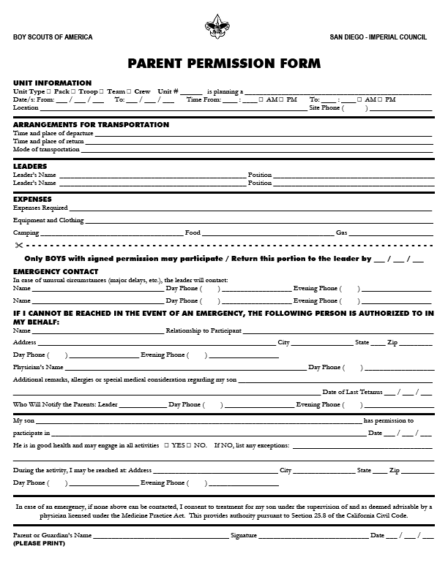

Pack 608 2008 Summer Activities

Lake Elsinore Storm baseball game - Saturday 6/21/2008 or Saturday 7/26/2008

Rock Climbing at Solid Rock – Sunday 8/17/2008
Camping at Mission Trails Regional Park – 8/1/2008-8/3/2008
Torrey Pines tide pool hike and nature center visit – June/2008 or July/2008

Transportation
All transportation is to be arranged by the family of each individual boy

Leaders
Pack 608 Committee members and Den leaders

Expenses
Per the individual event information provided by Pack 608

